

**National Institute of Technology, Silchar**

***CS 312: Database & Management System***

***(DBMS Project)***

# Restaurant Management System

*Prepared by: -*

*Mohith Sai Teja Kothapalli (2112101)*

*Mummidi V Ventaka Satyanarayana (2112102)*

*Swapnil Nath (2112103)*

*Anubhav Chakraborty (2112104)*

*Parimi Vedavalli (2112105)*

**Title:** *Restaurant Management system*

**Problem Statement:**

**A Restaurant Management System (RMS) is a comprehensive software solution that streamlines and automates various aspects of restaurant operations, from order taking and payment processing to inventory management and customer relationship management. RMS helps restaurants improve efficiency, reduce costs, and enhance customer satisfaction. Key features of an RMS include point-of-sale (POS) functionality, inventory tracking, table management, employee scheduling, customer data analytics, and online ordering integration. RMS solutions can be cloud-based or on-premise, catering to the specific needs and budget of each restaurant.**

The restaurant industry is highly competitive and demands efficient management to succeed. A Restaurant Management System (RMS) is essential for optimizing operations and providing a seamless dining experience. Our project aims to develop a comprehensive and user-friendly RMS database, catering to the diverse needs of restaurant staff, management, and customers.

* **Background:**

Restaurants, whether small cafes or fine dining establishments, handle a multitude of tasks daily. This includes managing user accounts, tracking client information, categorizing products, taking orders, and more. An effective RMS can streamline these processes, leading to improved customer satisfaction, cost control, and overall profitability. Our project seeks to address these needs by creating a well-structured database and user interfaces for staff and management.

* **Project Scope:**

The project's primary goal is to design and implement a relational database schema for a restaurant management system, incorporating tables for Users, Clients, Categories, Products, Tables, Orders, and OrderProducts. The system will ensure data integrity through foreign key constraints and maintain relationships between these entities.

* **Approach of Solving**:

The approach to solving the problem of creating a restaurant management system involves several structured steps:

1. *Requirements Gathering*: Understanding the specific needs of the restaurant, including functionalities required for user management/client management, cusine and menu handling, table reservations and table creation, order processing, inventory control, reporting.

2. *Design and Planning*: Creating a detailed plan by visualizing the system architecture, user interface, database schema, and system components. Deciding on the technology stack, security measures and integration.

3. *Database Design*: Developing an efficient database structure considering entities like users, cuisines, tables, orders, order_products, products and relationships between them. Ensuring data integrity and efficient storage.

4. *Development*: Implementing the system using appropriate programming languages and frameworks for the frontend, backend, and database components. Writing code, following best practices, and maintaining modularity for scalability.

5. *Iterative Improvement*: Gathering feedback post-implementation to identify areas for enhancement. Continuously updating and improving the system to adapt to changing business needs and technology advancements.

This structured approach ensures a systematic development process, enabling the creation of a robust and tailored restaurant management system that fulfills the restaurant's operational requirements and provides an efficient user experience.

* **Features and Functionalities**:

-A restaurant management system is a software solution designed to streamline various operations within a restaurant, facilitating efficient management of users, cuisines (food items), and tables. Here is a description of such a system:

***User Management*: -**

1. *Admin/User Roles*: The system distinguishes between different user roles (e.g., admin, staff, chef, cashier).

2. *User Authentication*: Secure login system with authentication methods to ensure authorized access to the system's functionalities.

**Cuisine Management: -**

1. *Cuisine/Categories:* The system organizes food items into categories (e.g., Continental, Indian, American,Mexican) for easy navigation and management.

2. *Food Products:* The system allows creation of different food products under the created categories and also takes the stock of each product as input.

3. *Menu Management*: Allows addition, modification, and deletion of food items, including details like name, price, available quantity, and category affiliation.

4. *Inventory Control*: Tracks stock levels, generates alerts for low stock, and manages inventory replenishment.

***Table Management: -***

1. *Table Layout*: Visualization of the restaurant layout with details on each table's occupancy status, capacity, and location.

2. *Table Reservation*: Facilitates table reservations, allowing customers to book tables.

3. *Occupancy Tracking*: Updates table status in real-time (occupied/vacant) and manages seating arrangements efficiently.

***Order Processing: -***

1. *Order Creation*: Enables creation of new orders with options to select table, add food items, and specify quantities.

2. *Order Modification*: Allows customization of orders, including additions, removals, or modifications of food items before finalization.

3. *Billing and Payment*: Calculates the total bill based on selected items, and facilitates payments.

***Technology Stack: -***

1. *Database*: Utilizes a relational database (e.g., **MySQL** and **SQL** language) to store and manage data.

2. *Backend*: Implements server-side logic using frameworks like **Node.js**/ **Express.js**, **bycrpt**, **jsonwebtoken**, **react-modal**, **nodemon**.

3. *Frontend*: Utilizes web technologies likeframeworks (**React.Js**, **react-redux**, **react-router-dom** and **react-modal**) and (**HTML**/**CSS**/**JS**, **Bootstrap**) for a user-friendly interface.

4. *Security Measures*: Implements encryption, secure authentication, and authorization protocols to protect sensitive data.

***Summary: -***

A comprehensive restaurant management system encompasses user management, cuisine management, table management, order processing, and additional features to enhance operational efficiency, customer service, and overall business performance. The system integrates various functionalities to streamline restaurant operations, providing a cohesive platform for staff and enhancing the dining experience for customers.

* **Challenges:**

The project faces several challenges, including:

**Data Integrity**: Ensuring that data in the database is accurate and consistent. Foreign key constraints must be implemented correctly to maintain referential integrity.

**User Authentication and Authorization**: Developing a robust system for user authentication and authorization to protect sensitive data and ensure secure access.

**Performance Optimization**: As the system will handle a large volume of transactions, performance optimization is critical to reduce latency and provide a responsive user experience.

**Customization**: Building user interfaces for different roles (admin, waiter, chef) that cater to their specific needs and workflows.

**Scalability**: Designing a database structure that can accommodate future expansion, potentially including multiple branches or locations.

­­­

## **ER DIAGRAM**

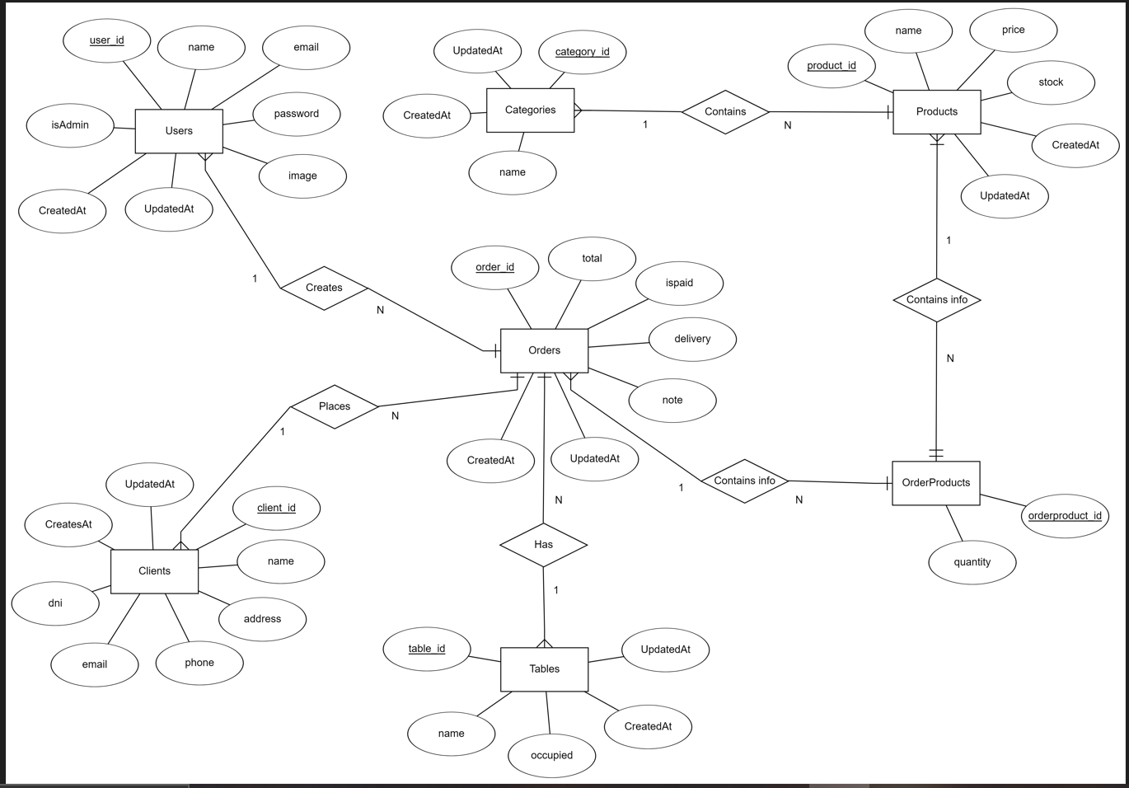

***ER Analysis Identifying Entity Sets and Relationship Sets:-***

*Entity sets*: -

1. *User -*
   * Userid
   * Email
   * Name
   * Password
   * IsAdmin
   * Image
   * CreatedAt
   * UpdatedAt

1. *Category-*
   * Category_id
   * Name
   * UpdatedAt
   * CreatedAt
2. *Tables*-
   * Table_id
   * Name
   * Occupied
   * UpdatedAt
   * CreatedAt
3. *Products*-
   * Product_id
   * Name
   * Price
   * Stock
   * UpdatedAt
   * CreatedAt

1. *Orders*-
   * Order_id
   * Delivery
   * Total
   * Ispaid
   * CreatedAt
   * UpdatedAt
   * Note

1. *Clients*-
   * Client_id
   * Name
   * Email
   * Phone
   * Address
   * DNI
   * CreatedAt
   * UpdatedAt
2. *OrderProducts*-
   * Order_id
   * Quantity ­­­­­­

## **Entity Sets**

1. *Users:*

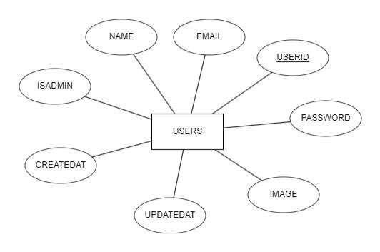

1. Categories:

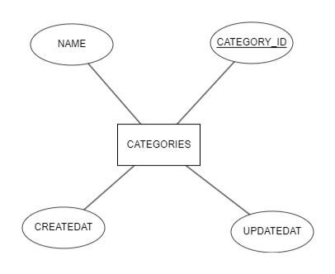

1. *Tables:*

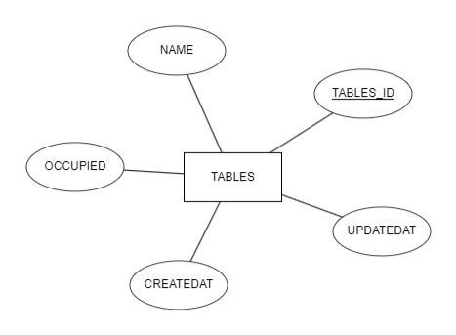

1. *Product*s*:*

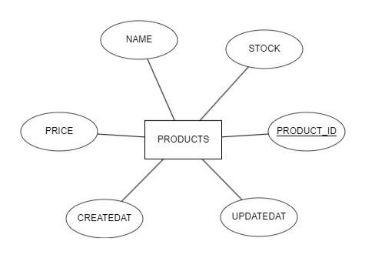

1. *Orders:*

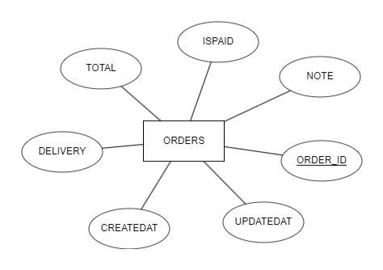

1. OrderProducts:

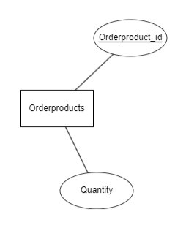

1. *Clients:*

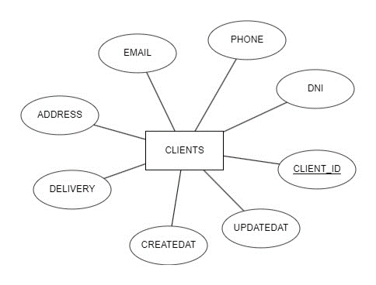

**RELATIONAL SCHEMA**

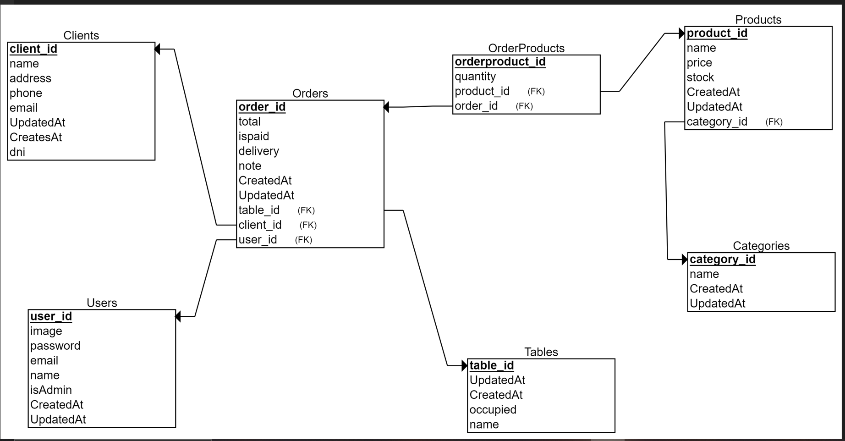

**Schema and Tables**

1. *Users-*

* *Schema-*

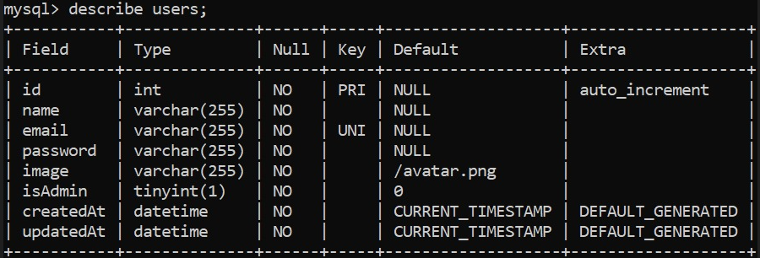

* *Table-*

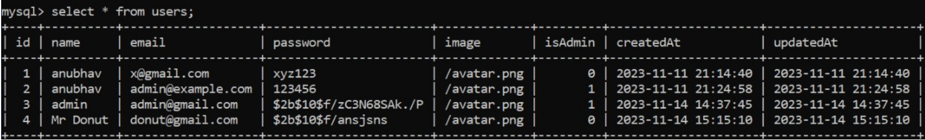

1. *Clients-*

* *Schema-*

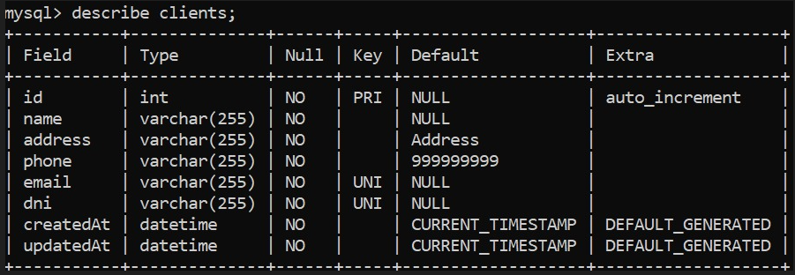

* *Table*

*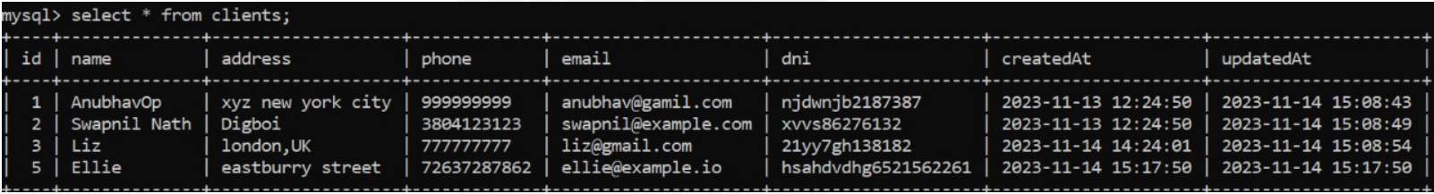-*

1. *Categories-*

* *Schema-*

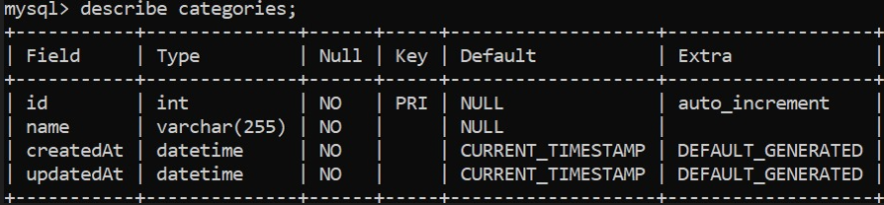

* *Table-*

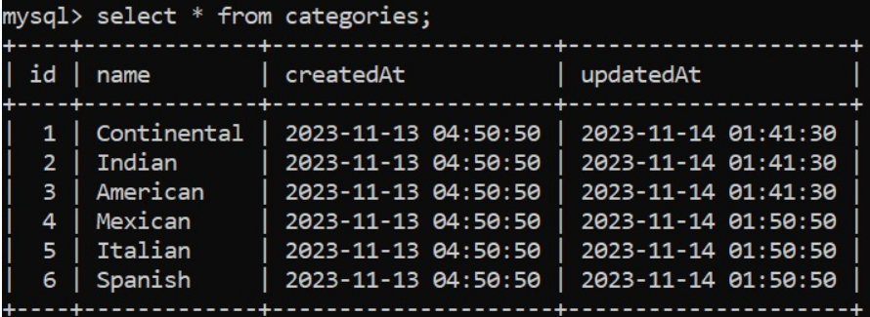

1. *Products-*

* *Schema-*

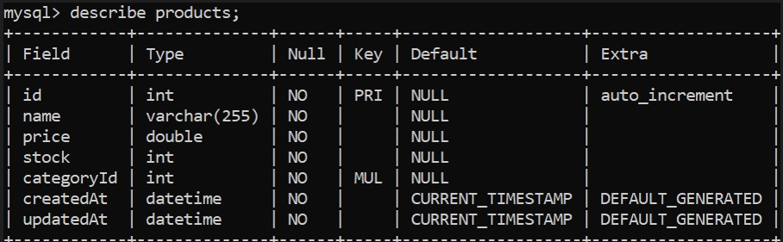

* *Table-*

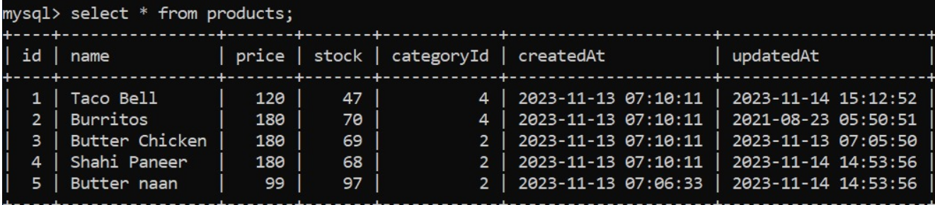

1. *Tables-*

* *Schema-*

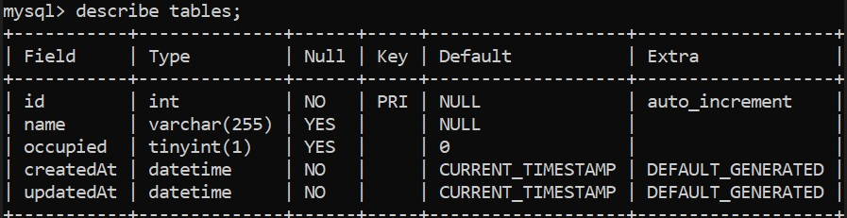

* *Table-*

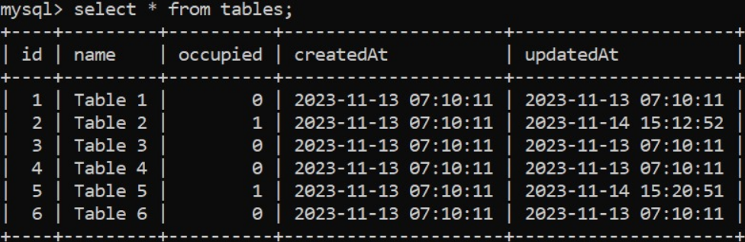

1. *Orders-*

* *Schema-*

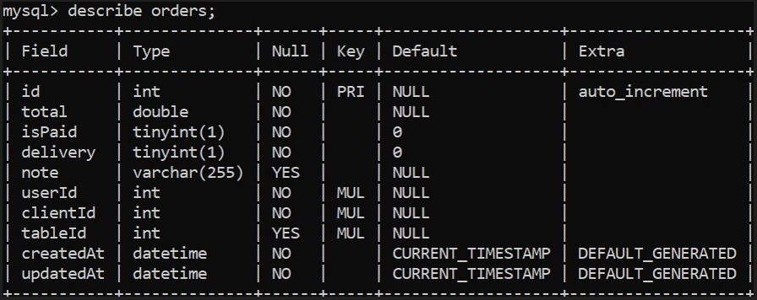

* *Table-*

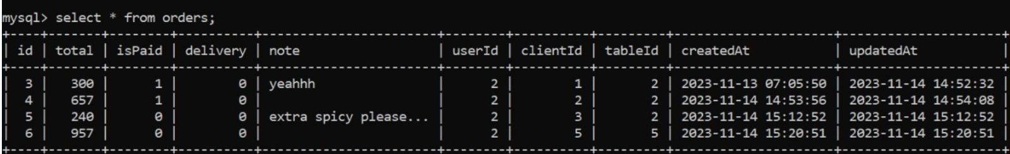

1. *OrderProducts-*

* *Schema-*

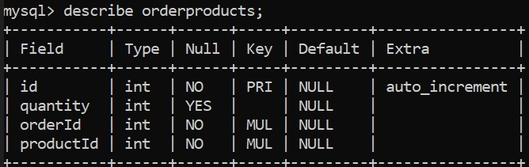

* *Table-*

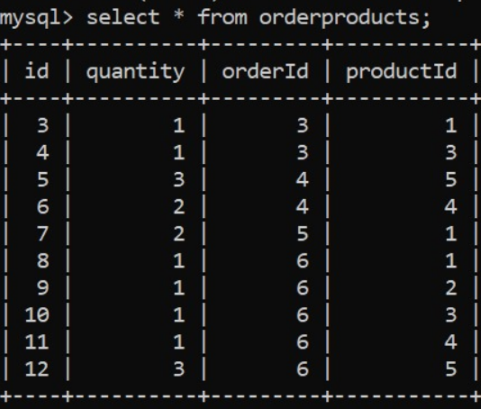

**User Interface**

*Screenshots-*

* Login Page UI

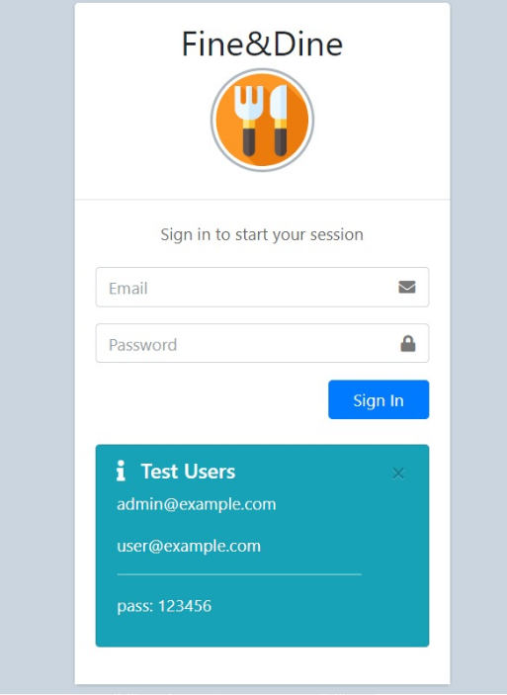

* Dashboard UI

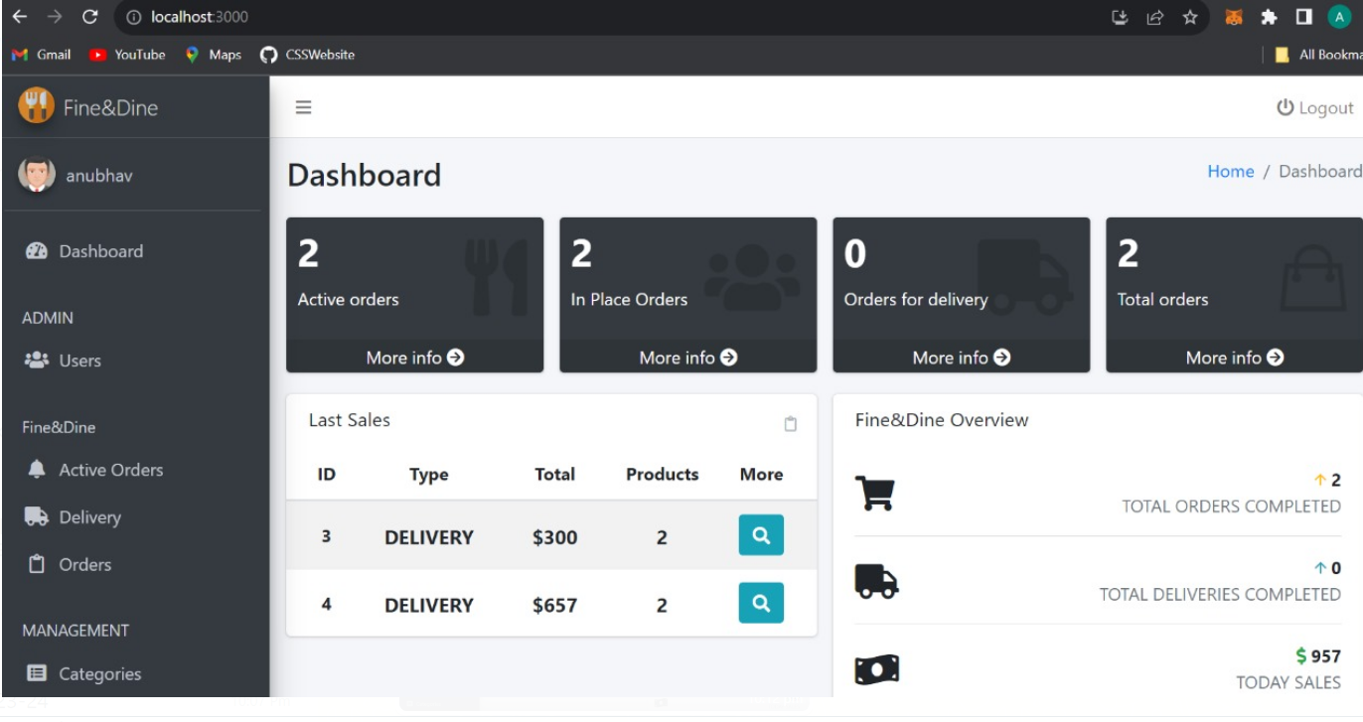

* Users UI

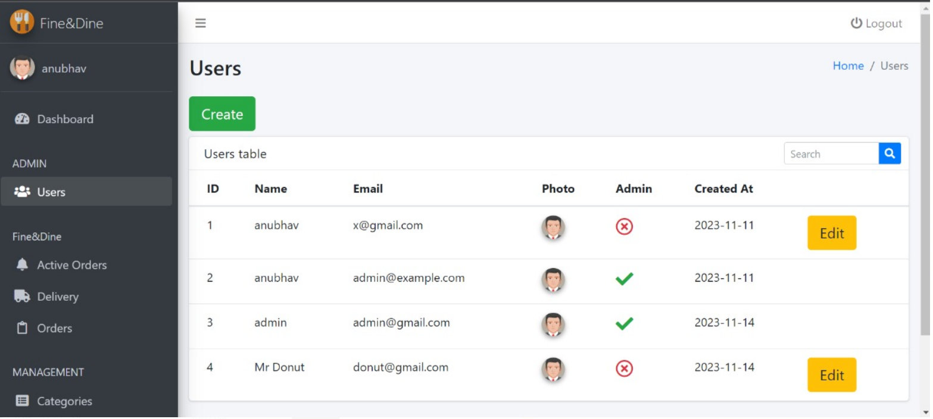

* Clients UI

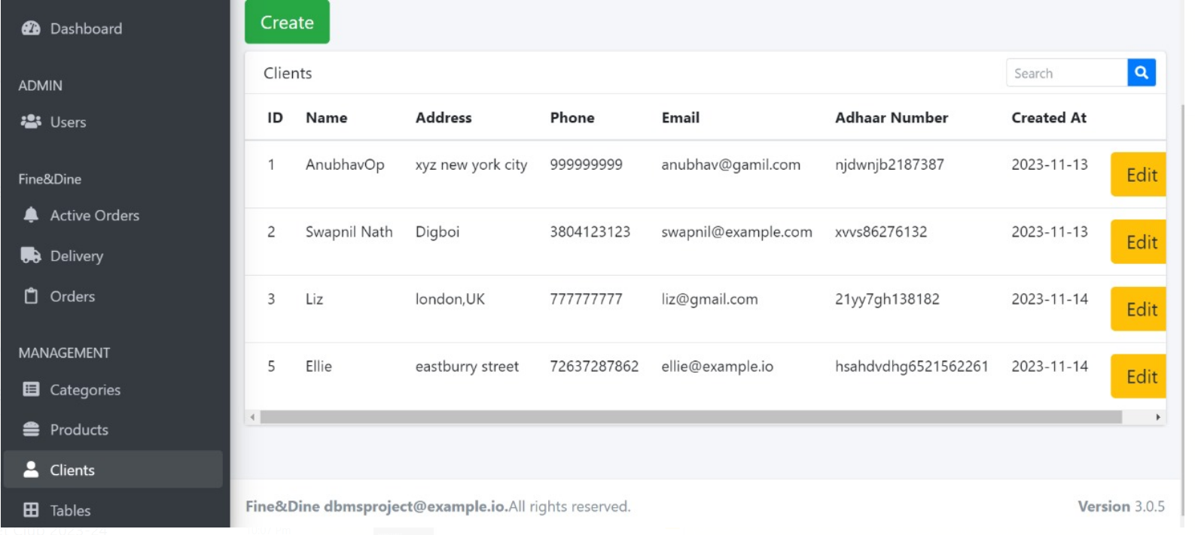

* Categories UI

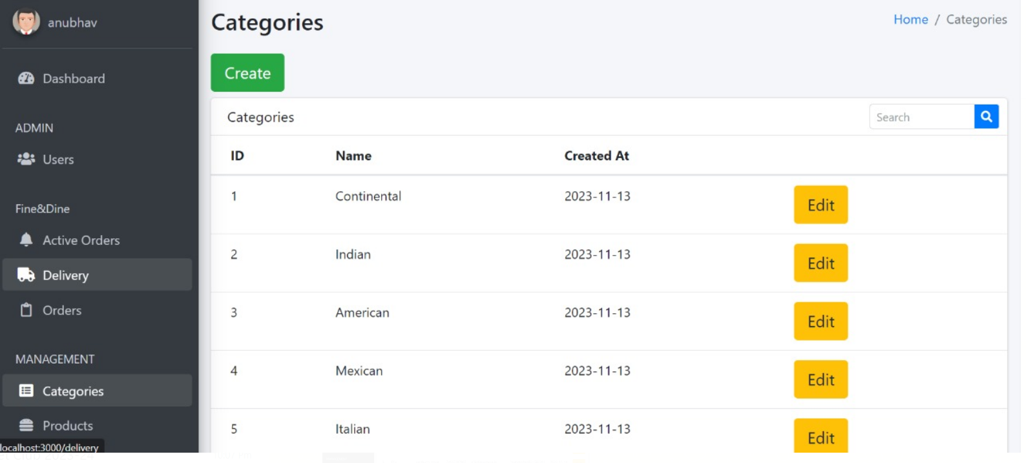

* Products UI

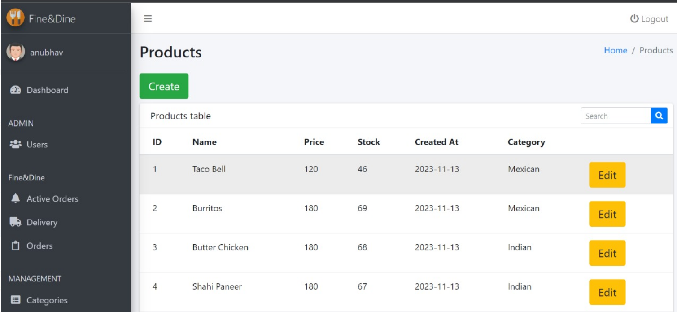

* Tables UI

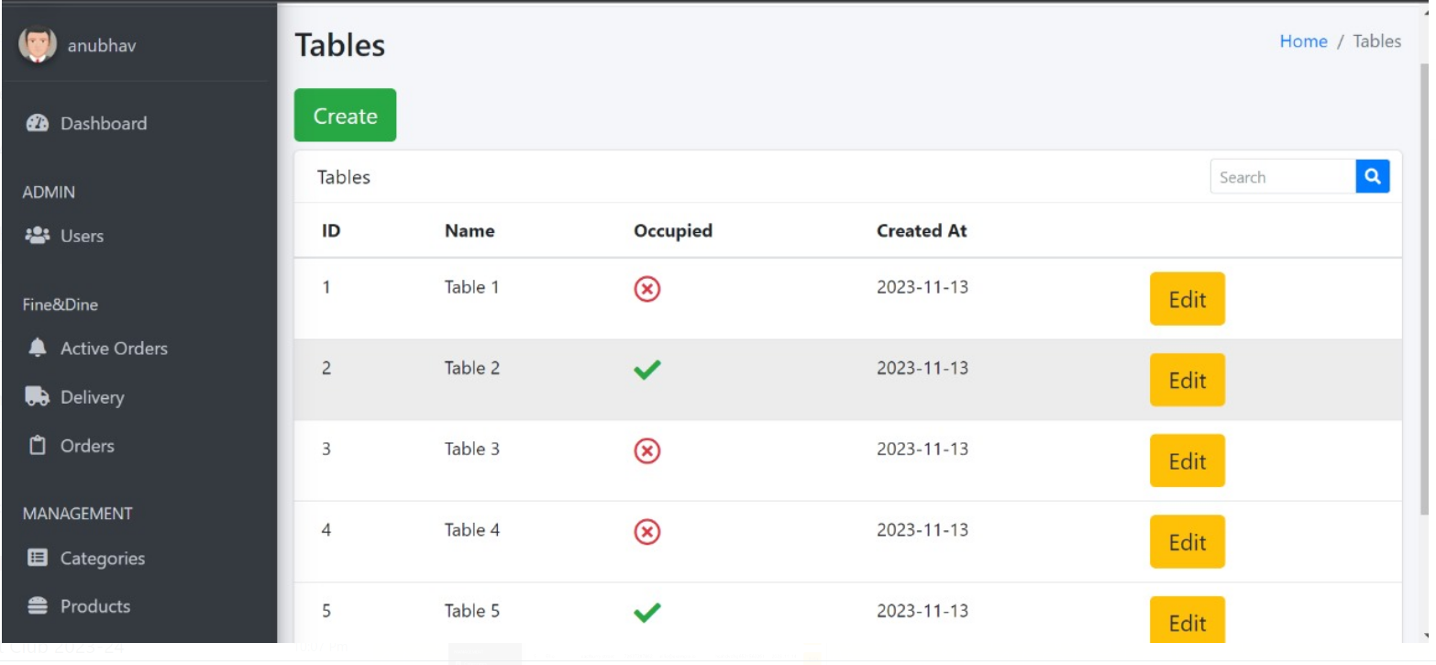

* Orders UI

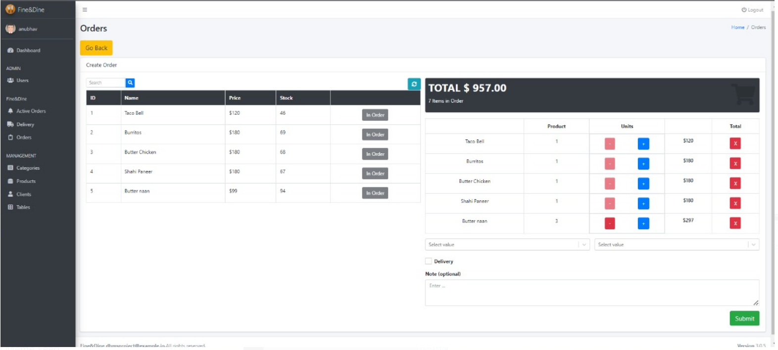

* Active Orders UI

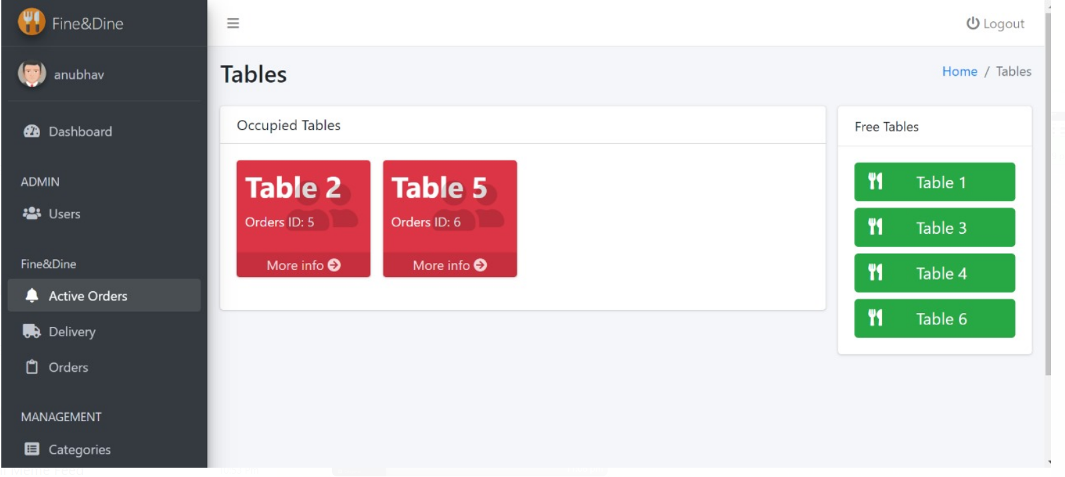

**References**

* Bootstrap, react-docs, express-docs is being used.
* Wikipedia, Investopedia is being used as reference for restaurant management.
* w3schools is used a reference for SQL (<https://www.w3schools.com/mysql/>)
* <https://express-validator.github.io/docs/> - it is used for database validation.